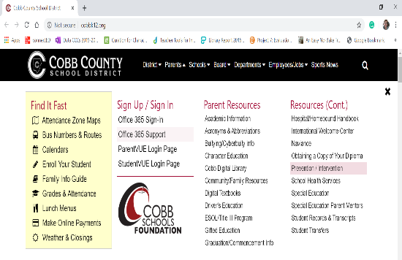
Let’s Log-in

Cobb Digital Library (Pebble go, Destiny, etc…)

- Go to http://www.cobbk12.org/
- Click on Parents Tab- Parent Resources
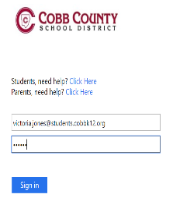
-Cobb Digital Library
- Go to https://cobb.mackinvia.com/
- Login- firstname.lastname@students.cobbk12.org
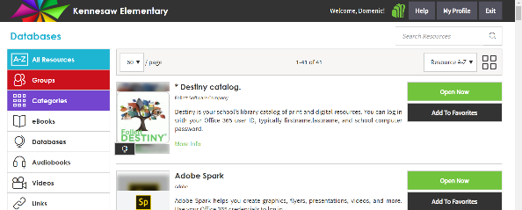
- Password: Cobb Password
- Search the resources.

Clever (one stop easy log in for several apps-Raz-kids, Headsprout, Dreambox, Sora, Studies Weekly, Brainpop)

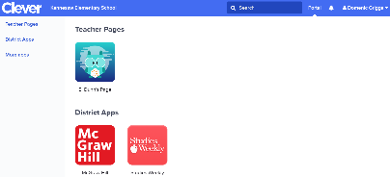
- Go to www.clever.com/in/cobb/student/portal
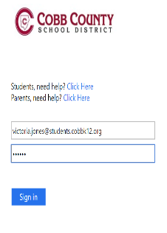
- Click on Active Directory
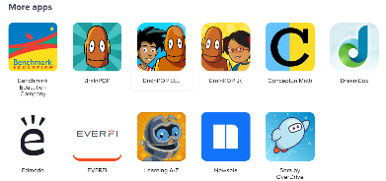
- Login- firstname.lastname@students.cobbk12.org
- Password: Cobb Password
- Search the resources.

